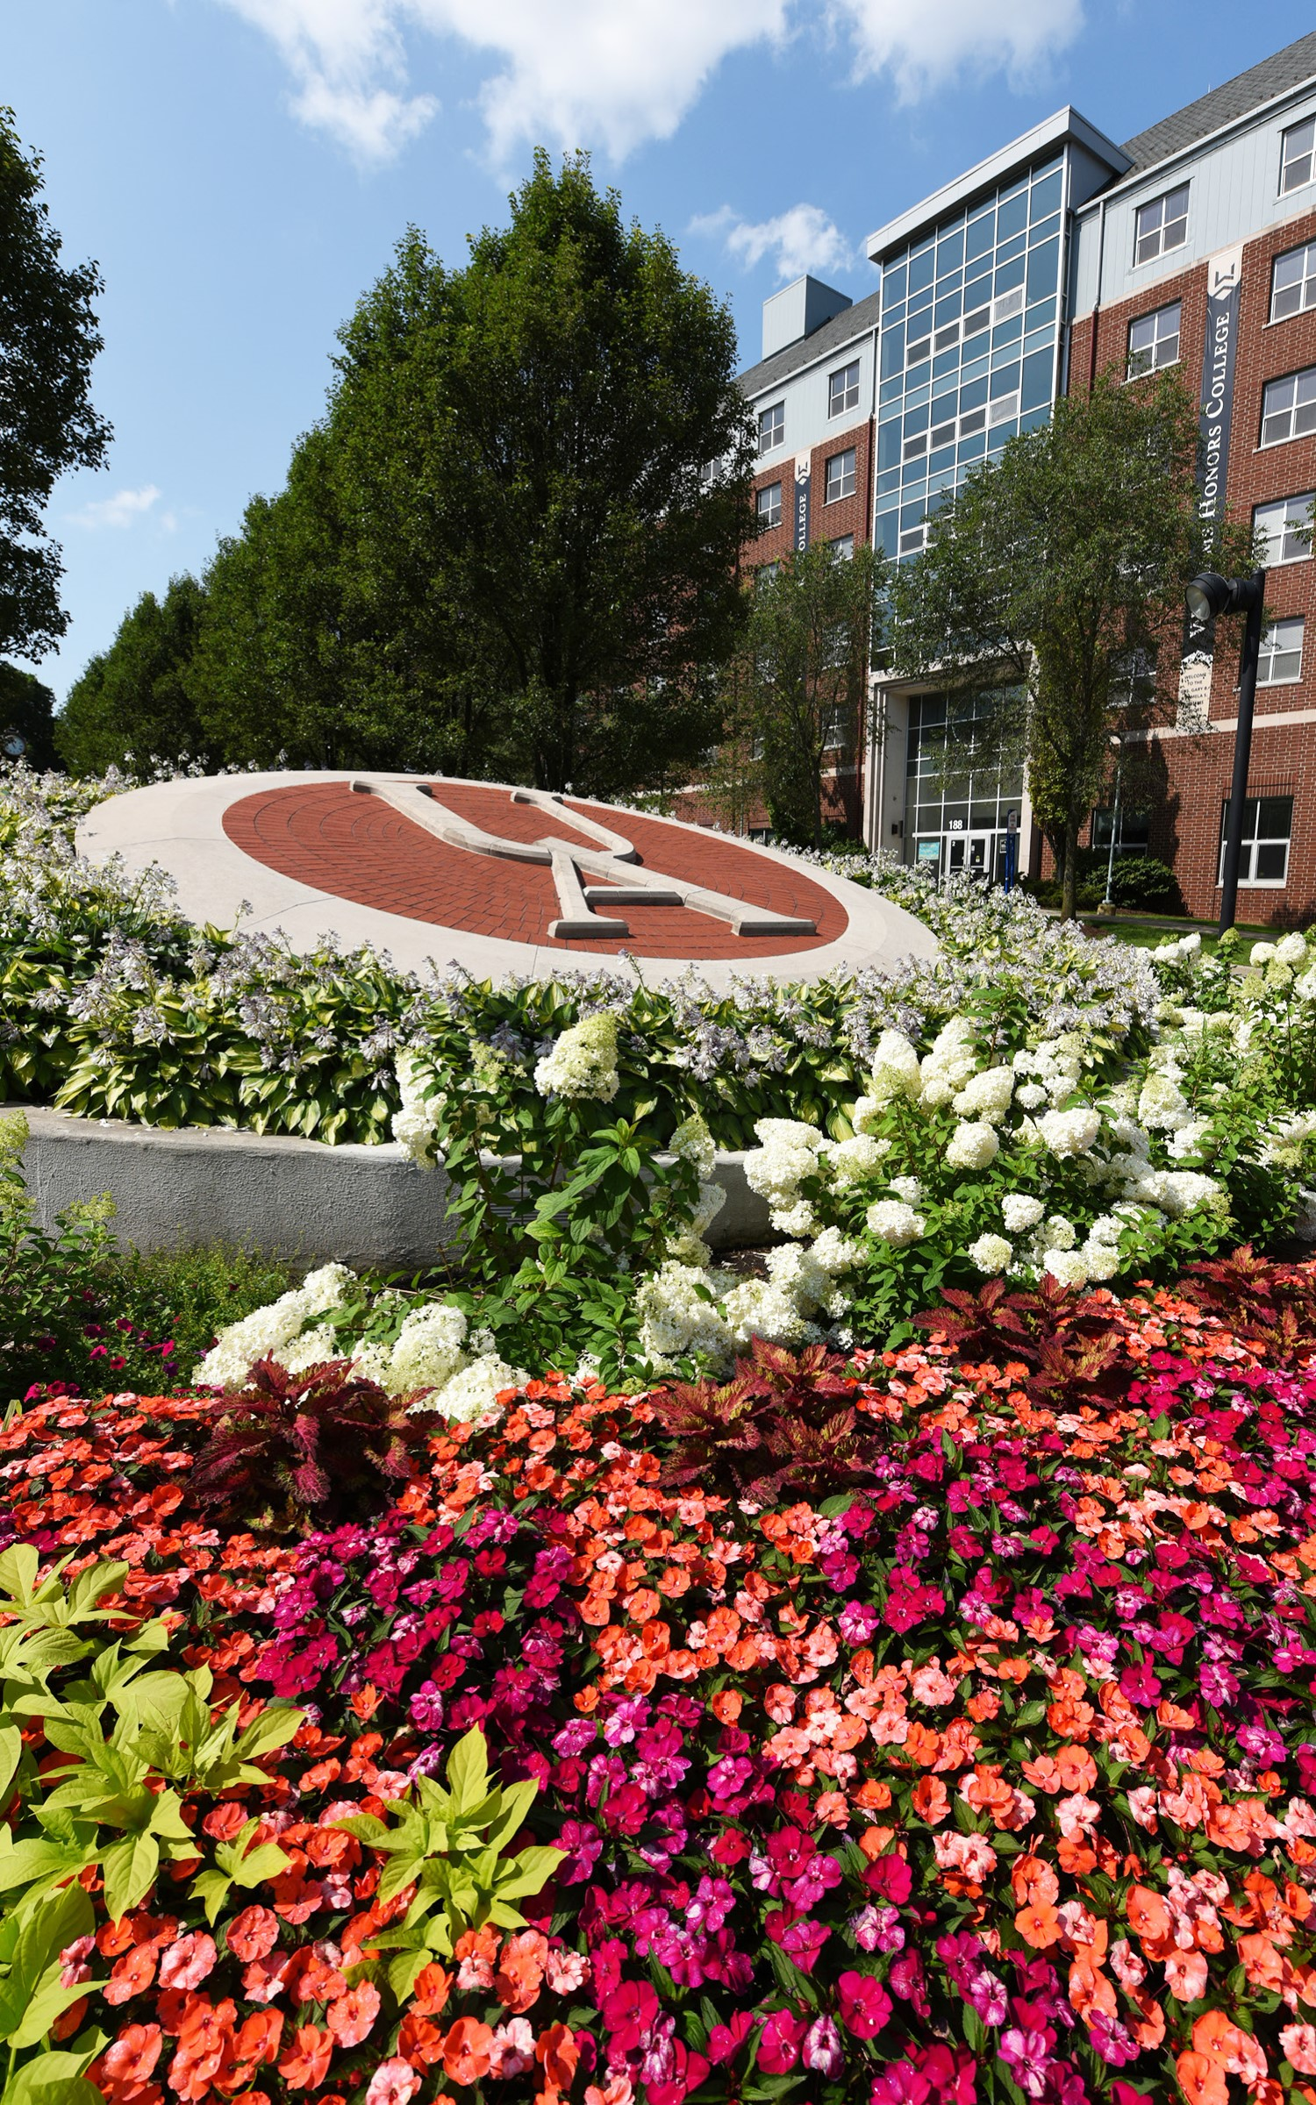

**THE UNIVERSITY OF AKRON**

**Counseling & Testing Center**

*We are here to help!*

**SIMMONS HALL 306**

**330.972.7082**

**www.uakron.edu/counseling**



Our Services

We provide comprehensive culturally responsive psychological

counseling and testing services

Personal Counseling

Group Counseling

ADHD, LD and personality assessment

Workshops/Outreach:

wellness, study skills, diversity & more

Online mental health information

Career Exploration Counseling

Consultation

*For Testing Services, visit www. uakron.edu/counseling/testing*

We can help you...

Manage stress

Adapt to life as a college student

Decrease anxiety and depression

Understand yourself and your family

Communicate and develop relationships with others

Explore your identity

Manage oppression and injustice

Cope with trauma

Discuss choices around alcohol/drugs

Identify your strengths

And More!

Counseling is free & confidential

Visit our webpage:

www.uakron.edu/counseling